**Exercise 1: Setting Up Junit**

**Scenario** : You need to set up JUnit in your Java project to start writing unit tests.

**1**. Created a New Maven Project in IntelliJ

* Opened IntelliJ IDEA → File → New Project.
* Selected Maven and provided:
  + GroupId: com.example
  + ArtifactId: Junit_Testing
* Chose the default location and finished creating the project

**2.** Added JUnit Dependency in pom.xml

* Opened the pom.xml file.
* Added the following inside the <dependencies> tag to include JUnit 4:

<dependency>

<groupId>junit</groupId>

<artifactId>junit</artifactId>

<version>4.13.2</version>

<scope>test</scope>

</dependency>

* Reloaded Maven to download the dependencies.

**3**. Created Application Code (Calculator.java)

* Navigated to src/main/java/com/example.
* Created a new class: Calculator.java

package com.example;

public class Calculator {

public int add(int a, int b) {

return a + b;

}

}

**4.** Created Test Package and Class (CalculatorTest.java)

* Navigated to src/test/java.
* Right-clicked and created a new package: com.example.
* Inside that package, created a new Java class: CalculatorTest.java.

package com.example;

import org.junit.Test;

import static org.junit.Assert.assertEquals;

public class CalculatorTest {

@Test

public void testAdd() {

Calculator calc = new Calculator();

int result = calc.add(3, 4);

assertEquals(7, result); // Test passes

}

}

**5**. Verified the Project Structure

Junit_Testing/

├── src/

│ ├── main/java/com/example/Calculator.java

│ └── test/java/com/example/CalculatorTest.java

├── pom.xml

**6.** Ran the Test

* Right-clicked CalculatorTest.java → Selected Run 'CalculatorTest'.
* The test executed successfully with a green checkmark.

**Final Outcome:**

Case 1: Test PASSED  
  
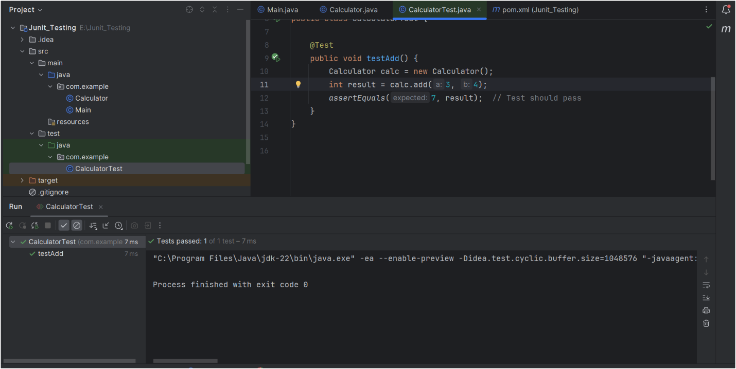

Case 2: Test FAILED  
